**Lab 13**

**Serial Communication**

**Objective:**

* To Learn how to how to communicate two 8051 micro-controllers serially.

**Components needed for this lab:**

* Keil µVision IDE
* Proteus Software
* 8051 Micro-controller

**8051 Micro-controller:**

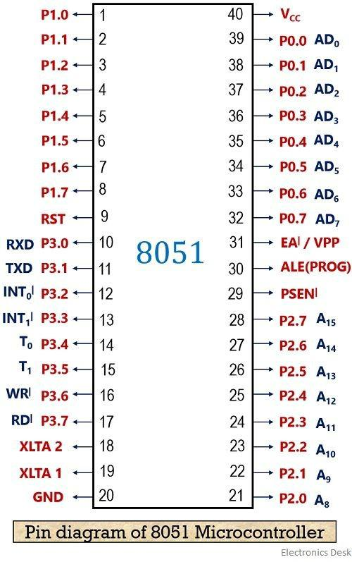

Fig 01: 8051 Pin Diagram

**Task:Perform serial communication between two 8051 micro-controllers.**

#include <reg51.h>

#include <studio.h>

#define input P1

sbit rd = P3^4;

sbit wr = P3^5;

sbit intr= P3^2;

void adc();

void serial_com();

void sample_rate(unsigned int i);

void main(void) {

serial_com();

while(1) {

adc();

SBUF = input;

while(TI==0);

TI = 0;

}

}

void adc() {

sample_rate(2);

rd = 1;

wr = 0;

wr = 1;

while(intr==1);

rd = 0;

}

void serial_com() {

TMOD = 0x20;

TH1 = 0xFD;

SCON = 0x50;

PCON = 0x00;

TR1 = 1;

}

void sample_rate(unsigned int i) {

for(i=0; i<125; i++) {}

}

8051 C Code to show 15 ms delay using timer0

Serial transfer

#include <reg51.h>

void serial_com() {

TMOD = 0x20;

TH1 = 0xFD;

SCON = 0x50;

PCON = 0x00;

TR1 = 1;

}

void main(void) {

serial_com();

while(1) {

while(RI==0);

RI = 0;

P1 = SBUF;

}

}

Serial reception

------------------------------------------------------------| Output |------------------------------------------------------------

